Rui Ling, [ruiling@stanford.edu](mailto:ruiling@stanford.edu)

Hao Li, [haoli94@stanford.edu](mailto:haoli94@stanford.edu)

Jiushuang Guo, [jguo18@stanford.edu](mailto:jguo18@stanford.edu)

CS108 FINAL DOCUMENTATION

**General Layout**

Welcome to our Bunny World Game Play and Editor App! When starting our game, you will be directed to the main page, where you can select the app mode between “Create Game”, “Play Game”, and “Edit Game.” If you choose “Create Game” by clicking the button, you will be directed to a new activity where you can create a new game. You will also see a spinner on main page, where you can choose an existing game, either to be played or to be edited. If you click the “Edit Game” button, you will also be directed to the activity that you can re-edit the existing game. By choosing “Play Game” button, you can play the game selected in the spinner. How Exciting! Our app will provide a default game called “Bunny World,” so that you can always have a taste of how games are played in the play mode or showed in the edit mode.

**Play Mode**

Welcome to play the game that you just created or the default game. The play mode will load the game information from the sql table (table name equals game name), then it can draw the shapes on our customized canvas, allowing many fancy effects, including the required effects and many extensions.

**Requirements**: In the play mode, our game has met all the requirements listed in the handout:

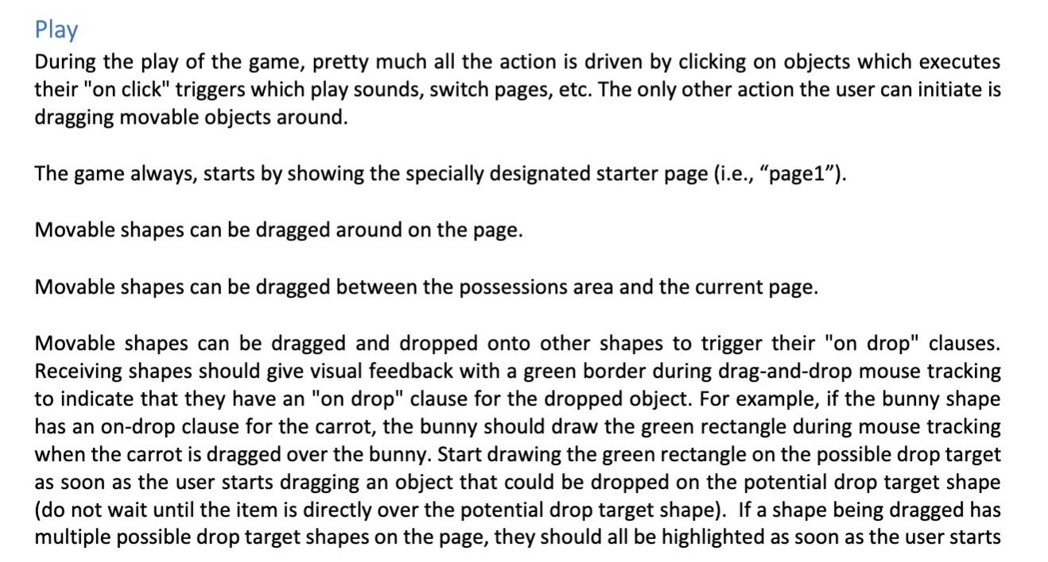



**Editor Mode**

Welcome to our editor mode, where you can either create a new game by clicking the “Create Game” button on main page or edit an existing game by choosing an existing game from the spinner in main page and click “Edit Game.” Just use our easy handling and user friendly edit mode to create your own game world! In the edit mode, our game has met all the requirements listed in the handout as below:

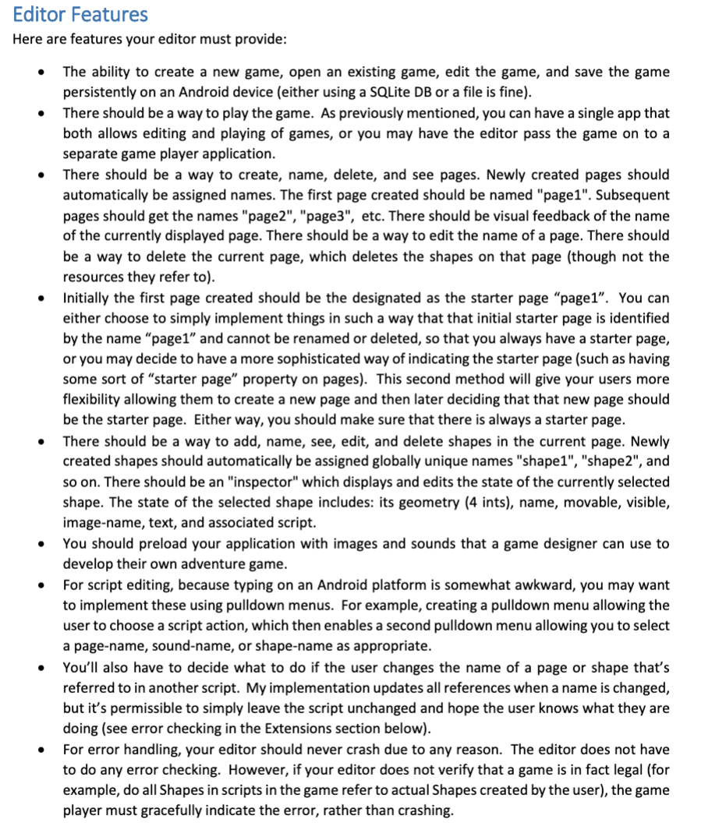

**EXTENSIONS:**

**Main Page Extensions:**

* On main page, you can see some UI features like a app name with rich text (textcolor, text with shadow, text with different font) and a app logo (a game handle picture).
* A “Delete Game” Button to delete the existing game (except bunny world).
* A “Reset Database” Button to delete all other games rather than the default game bunny world, to give user a more convenient way/friendly UI experience to reset everything.

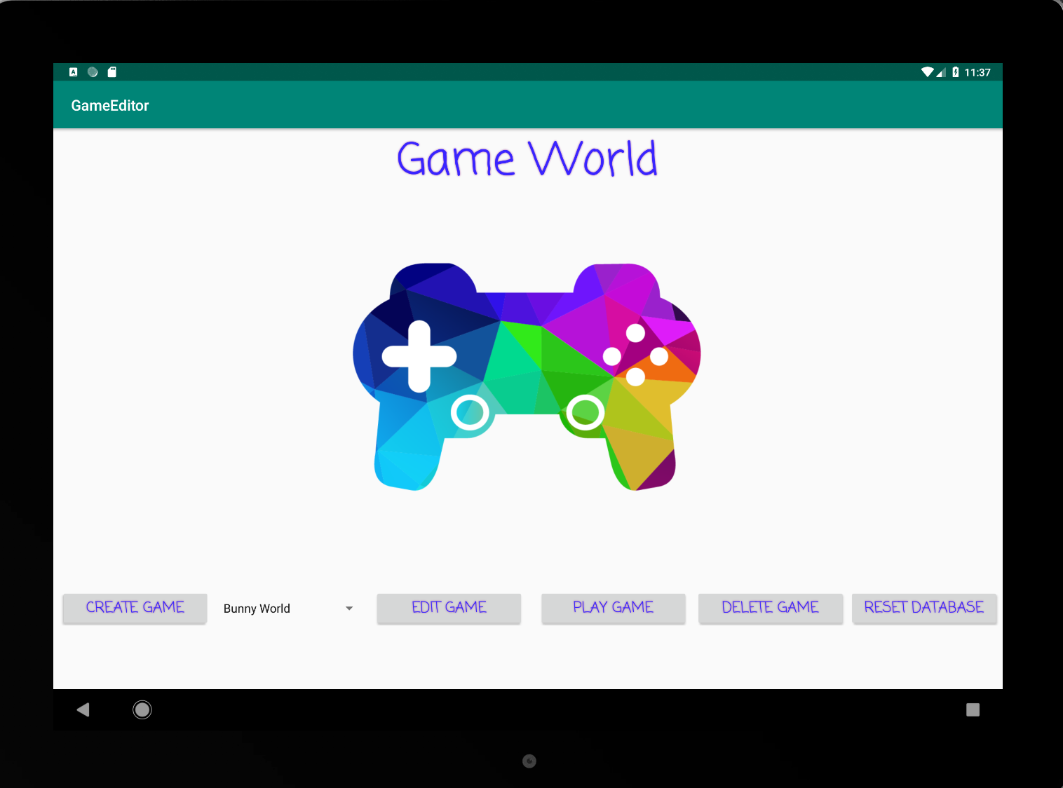

**Play Mode Extensions**

Besides these required effects, we have added play feature extensions as below:







* Add background image when playing the games

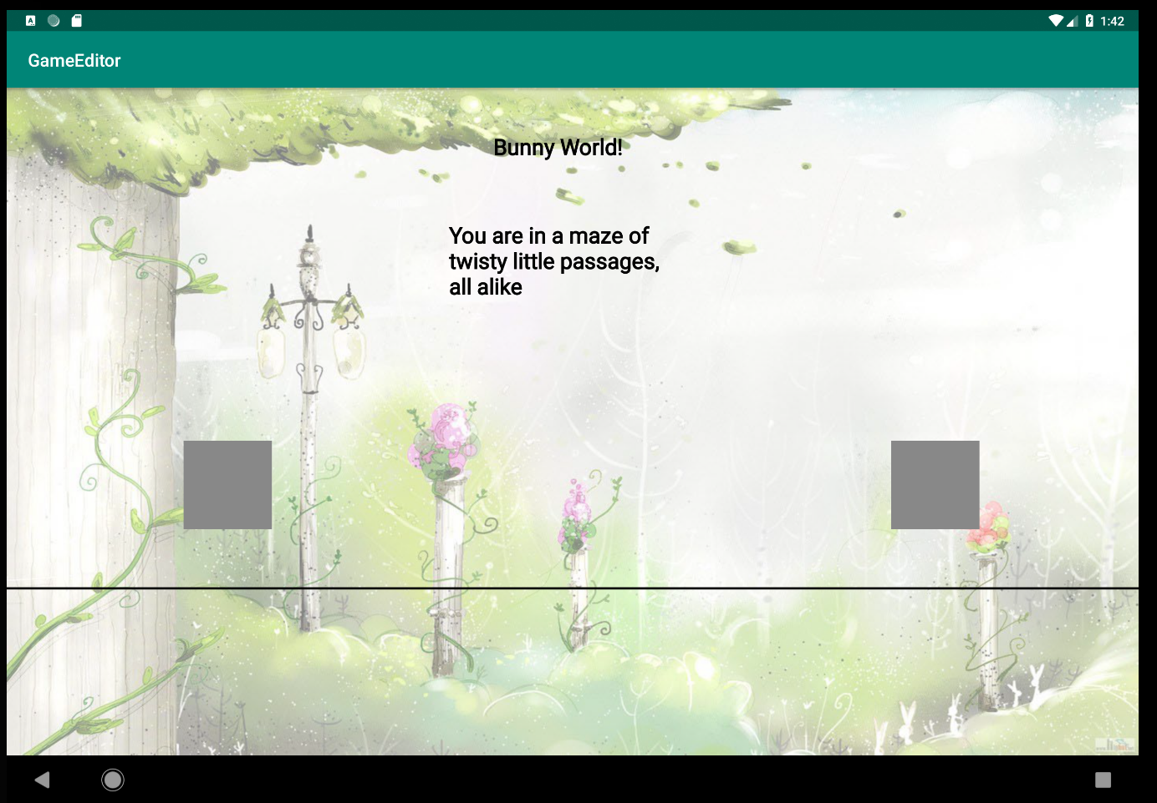

**Editor Mode Extensions**

Besides these required effects, we have added other editor feature extensions as listed below:

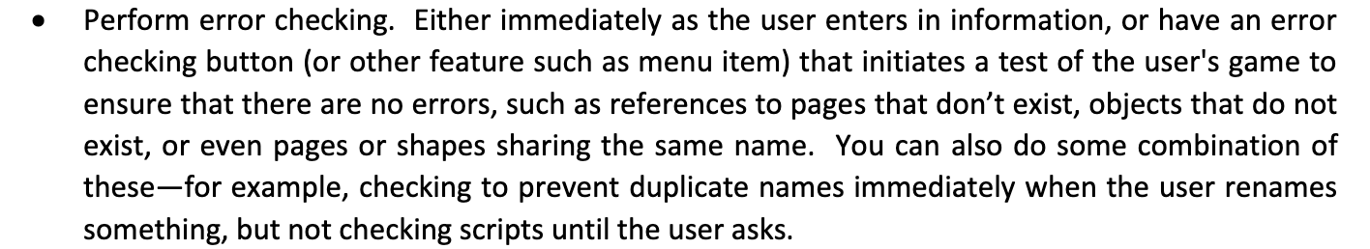





* Alert Dialogs to alert users for some non-undoable operations like removing a page and overwriting an existing game.

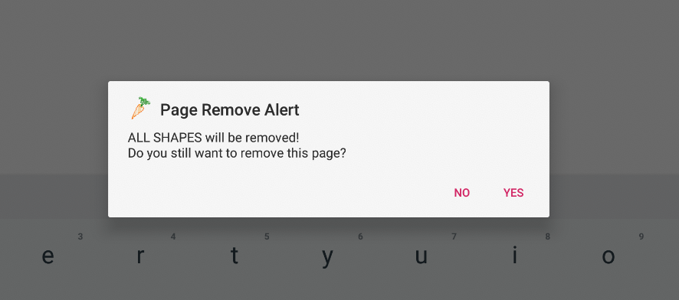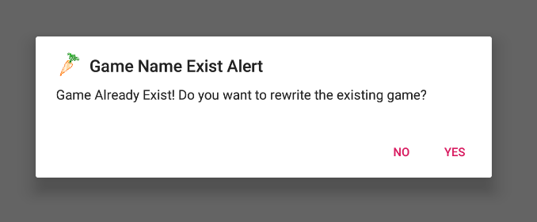

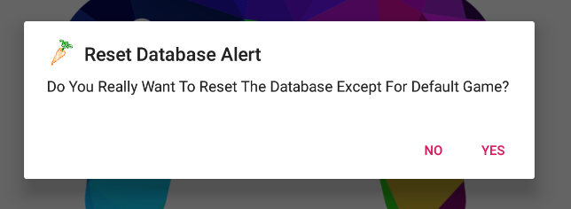

* Dynamic update on positions of the shape being dragged around. When dragging a shape /moving the shape around, you can see the positions of the shape dynamically updated on the right panel, so that you can have a very clear idea of what location the shape is located right now.

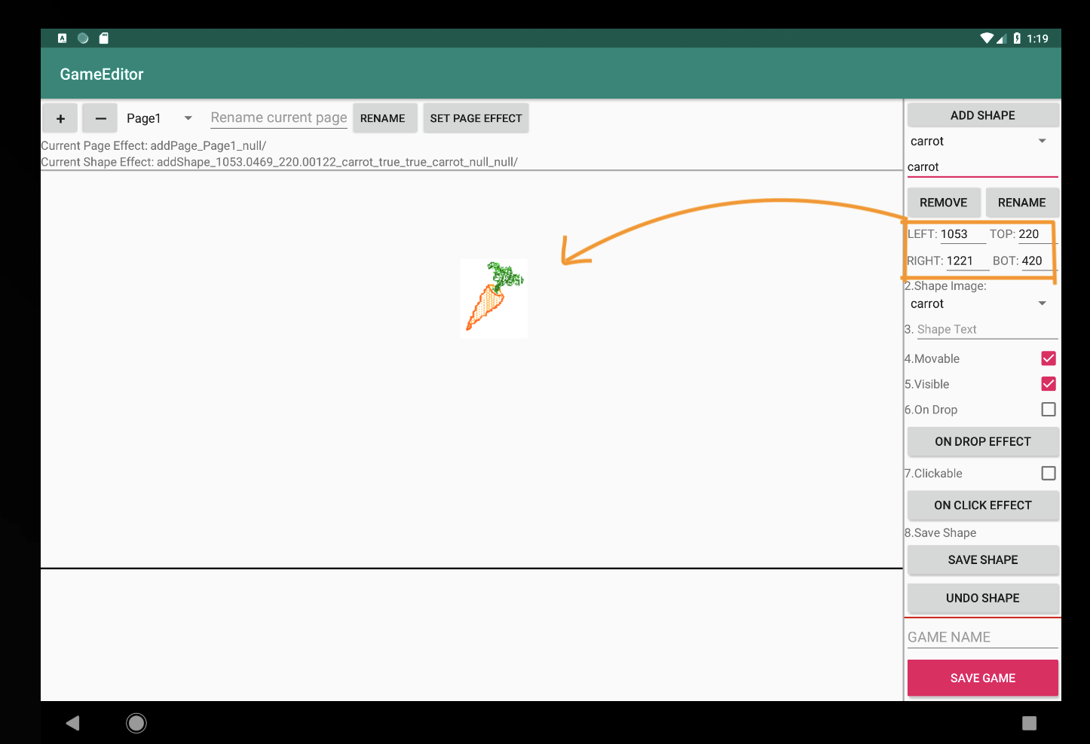

* Current added onDrop, onClick, and onEnter effects will show up in three custom view lists, with a remove button at each row for users to easily remove a piece of effect. This custom view will change programmatically with different shapes, but can be retrieved to correct corresponding list when switching back.

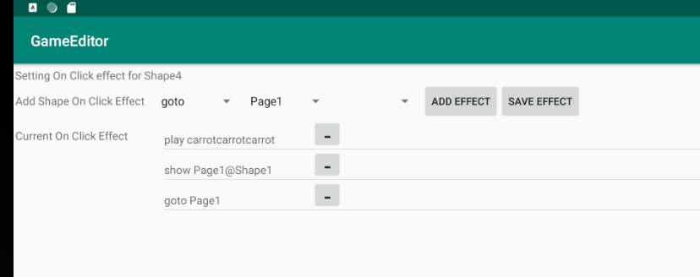

* Allow users to define drop effect on a category of object. For example, the bunny can hide all carrots(as a carrot category) that dropped on it (no matter what name this carrot called, and no matter what page this carrot belongs to). It can also apply the effect to everything that is dropped on it!

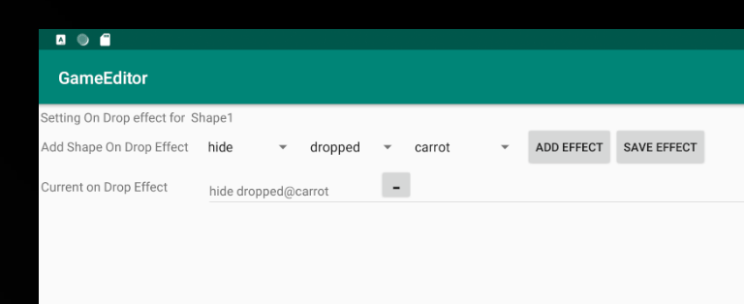

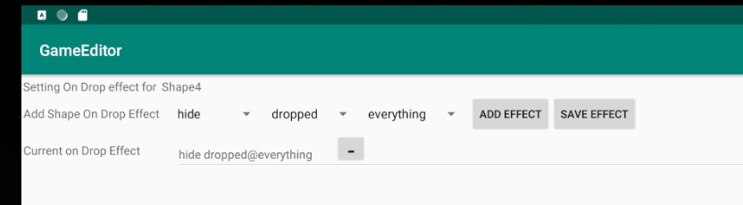

THANK YOU FOR PLAYING, CREATING, AND EDITING GAMES

IN OUR APP!

Reference

1. <https://stackoverflow.com/questions/35708453/how-to-automatically-click-a-button-in-android-after-a-5-second-delay>
2. <https://stackoverflow.com/questions/17525886/listview-with-add-and-delete-buttons-in-each-row-in-android>
3. <https://stackoverflow.com/questions/4946295/android-expand-collapse-animation>